# Anomaly Detection in Network Traffic

# Aim -

Using unsupervised learning techniques such as isolation forests or autoencoders to detect unusual patterns or anomalies in network traffic data, which could indicate potential security breaches or system malfunctions.

# Theory –

In an era of big data, anomaly detection has become a crucial capability for unlocking hidden insights and ensuring data integrity. This blog dives into the world of unsupervised machine learning techniques to detect outliers efficiently without labelled data.

## **What is an anomaly?**

An anomaly is basically something that’s unusual, doesn’t fit the usual pattern, or stands out because it’s different in a specific category or situation. To explain it simply, let’s look at some clear examples:

* Think about a collection of smartphones, mostly from Samsung, and then there’s an iPhone. The iPhone is an anomaly because it’s a different brand.
* Imagine you have a bunch of pens, but one of them is a fancy fountain pen instead of a regular ballpoint pen. That fountain pen is an anomaly because it’s not like the others.

## **What is anomaly detection?**

Anomaly detection is a technique used to identify data points that are significantly different or “outliers” when compared to the majority of the data in a dataset.

Anomaly detection is about finding data points that are different from what is considered normal or expected, and it relies on historical data or established knowledge to determine what falls within the usual range. It plays a crucial role in ensuring the quality and security of data in various domains.

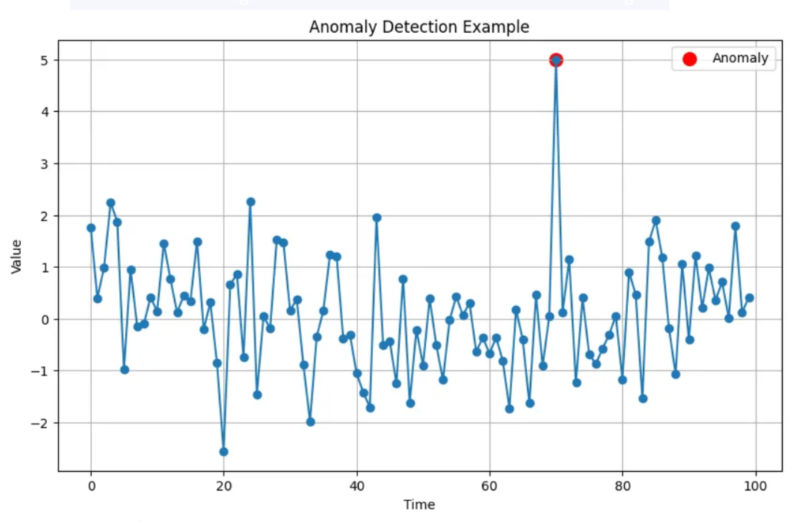

**Anomaly detection use cases**

Here are some diverse applications of anomaly detection using machine learning:

1. Event detection in sensor networks
2. Manufacturing quality control
3. Healthcare monitoring
4. Social media monitoring
5. Fraud detection
6. Network intrusion detection
7. Healthcare monitoring
8. Insurance claim analysis
9. Cybersecurity threat detection
10. Identity theft
11. Traffic monitoring
12. Network intrusion detection
13. Data breaches
14. Intrusion detection
15. Video surveillance

# Here are some common approaches to anomaly detection:

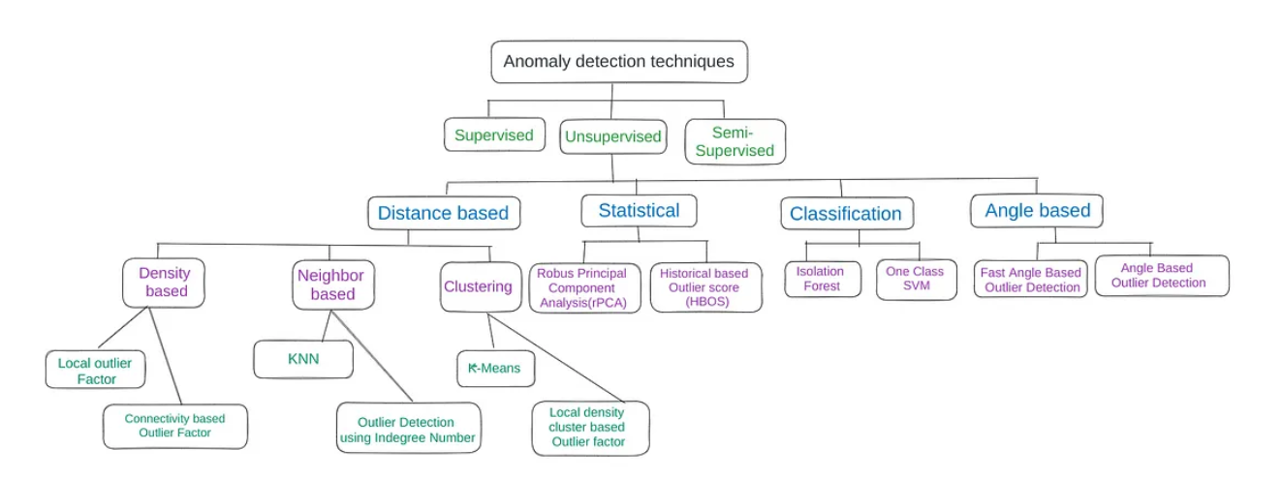

# What is Anomaly detection in network traffic ?

Anomaly detection in network traffic is a critical aspect of cybersecurity, as it helps identify unusual patterns that could indicate security breaches, system malfunctions, or abnormal behaviour. Here is a brief overview of the theory behind anomaly detection in network traffic:

1. **Normal vs. Anomalous Behaviour:** Anomalies in network traffic can be broadly categorized into two types:
   * **Point Anomalies:** Individual data points that are significantly different from the rest of the data.
   * **Contextual Anomalies:** Patterns or sequences of data that are abnormal within a specific context but may appear normal in another context.
2. **Challenges in Network Traffic Anomaly Detection:**
   * **High Dimensionality:** Network traffic data is often high-dimensional, with a large number of features, making it challenging to detect anomalies visually.
   * **Imbalanced Data:** Anomalies are rare compared to normal instances in network traffic data, leading to imbalanced datasets.
   * **Dynamic Nature:** Network traffic patterns can change over time, requiring adaptive detection techniques.
3. **Anomaly Detection Techniques:**
   * **Statistical Methods:** Approaches like z-score, modified z-score, and percentile-based methods can identify anomalies based on statistical deviations from the norm.
   * **Machine Learning:** Techniques such as Isolation Forests, One-Class SVM, and Autoencoders are commonly used for anomaly detection in network traffic data.
   * **Deep Learning:** Deep learning models like Recurrent Neural Networks (RNNs) and Long Short-Term Memory (LSTM) networks can capture sequential patterns in network traffic data for anomaly detection.
4. **Feature Selection and Engineering:** Identifying relevant features from network traffic data and transforming them appropriately can improve the detection of anomalies. Features like packet size, protocol type, traffic volume, and timestamps can provide valuable information for anomaly detection.
5. **Evaluation and Validation:** It is essential to evaluate the performance of anomaly detection models using metrics like precision, recall, F1-score, ROC-AUC, and confusion matrices. Cross-validation techniques can help validate the model's generalizability.
6. **Response Strategies:** Once anomalies are detected in network traffic, organizations can implement response strategies such as alert notifications, blocking suspicious activities, conducting forensic analysis, and enhancing network security measures.

# How to solve Anomaly Detection in Network traffic ?

To address anomaly detection in network traffic data using unsupervised learning techniques such as isolation forests or autoencoders, you can follow these general steps:

1. **Data Collection and Preprocessing:**
   * Gather network traffic data from sources like network logs, packet captures, or telemetry data.
   * Preprocess the data by cleaning, normalizing, and selecting relevant features for anomaly detection.
2. **Feature Selection and Engineering:**
   * Identify important features such as source/destination IP addresses, port numbers, protocol types, packet sizes, timestamps, etc.
   * Transform and scale the features as needed to prepare the data for modelling.
3. **Model Selection and Training:**
   * Choose a suitable unsupervised learning technique like isolation forests or autoencoders for anomaly detection.
   * Split the data into training and validation sets if applicable.
   * Train the chosen model on the network traffic data.
4. **Anomaly Detection and Evaluation:**
   * Use the trained model to detect anomalies in the network traffic data.
   * Evaluate the model's performance using metrics such as precision, recall, F1-score, or ROC-AUC.
   * Fine-tune the model parameters if needed to improve detection accuracy.
5. **Response and Action:**
   * Investigate detected anomalies to understand their nature and potential impact.
   * Implement response strategies such as generating alerts, blocking malicious activities, or taking corrective measures to mitigate risks.
6. **Monitoring and Iteration:**
   * Continuously monitor network traffic data for anomalies and update the detection model as necessary.
   * Regularly review and refine the anomaly detection process based on new data patterns or emerging threats.

# Conclusion

Implementing anomaly detection in network traffic data using unsupervised learning techniques such as isolation forests or autoencoders is crucial for enhancing cybersecurity defences. By following key steps like data preprocessing, model training, anomaly detection, and response strategies, organizations can proactively identify and mitigate potential threats in network traffic effectively. Continuous monitoring and refinement of the anomaly detection process are essential for staying ahead of evolving cyber threats and maintaining a strong cybersecurity posture.